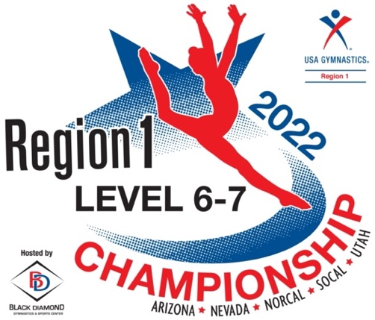
April 29~May 1st

Venue: Salt Palace Convention Center
100 S. West Temple
Hall #5 (Use “west entrance” off 300 W.)
Salt Lake City, UT 84101
Salt Palace Convention Center Information

Admissions: Single Session. . . $15 Adult or $10 Kids/Seniors
All Day Pass . . . . $30 Adult or $20 Kids/Seniors
Weekend Pass. . $75 Adult or $50 Kids/Seniors

Qualifying Score: 34.00⁺ at state championships

Lodging: 2022 Level 6-7 Regional Championships Lodging

Official Meet Leotard: Order by March 30th. Click Here!
~ This is a fundraiser designed to support Region 1 and its athletes.
~ $63 includes the custom leotard, tax and shipping.

Photography: JKP Sports will be taking action photos of all competitors at the event! Utilizing state of the art, facial recognition technology, parents and athletes will be able to view and purchase images right from their cell phones at the event! No more waiting in line to view images! Information will be handed out at the event with how to access images.

Competition Schedule: The schedule will be available by April 8th. Please do not have parents contact the host club as we cannot set the specific schedule until each state’s qualifying meets have concluded. Once entries have been received and schedule has been designed, it must be approved by the regional committee prior to sending out.

We intend to begin with the youngest athletes per level on Friday and work our way through the older age groups as the weekend progresses.

Contact for clubs and coaches only: blackdiamondcompetitions@gmail.com

